TOM-BOYCE FREE ENERGY DEVICE
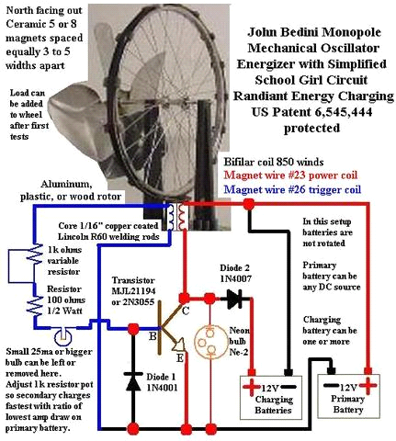

How do we generate and use electricity in the (near) future
In short this is what it does:
A pulse from a magnet on the wheel triggers the transistor.
The transistor switches ON and pushes the magnet away, and at the same time the transistor switches off, the stored energy in the coil is going to collapse and the only way it can go is into the charging battery. The next magnet arrives, and the process starts all over again.
And thus by capturing the used energy back into a battery and on top of that delivering mechanical energy to rotate the wheel. The wheel can power a fan a small pump, any other low torque device.
Diode1 and the Neon bulb protect the transistor.
The 'tricks' are in the bi-filair coil which captures the radiant energy and in the battery which transfers and stores the radiant energy.
Tom's version
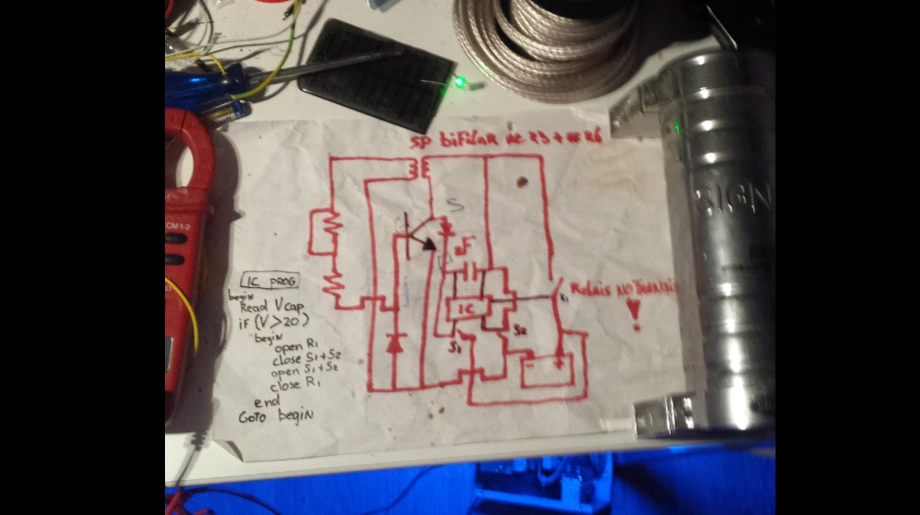
my version was to collect the radiant energy into a 2 farad capacitor witch you can see at the right, read the voltage on the cap trough a programmed microprocessor, and when it reach the 12 volt the switch s1 s2 and relais r1 will pump the capacitor back into the primairie batterie. I kept it going and while the lego wheel LOL with neomagnets run whole night the batterie charged from 12.45 to 12.57. then the alarm went of and yeah the secert service i gues...don't wanna go into that right now.

after that began studing more, watch bedini's video's over and over again and someday it clicked. TPU tutorial power unit.

TPU=EDC origianly from STEPHEN MARKS
research By Otto Sabljaric & Roberto Notte
first and most important !!!!!!
Please be informed that TPU=ECD could be and certainly is a very, very dangerous device and if you make it we don’t want to keep any kind of responsibility, so the advice is: make it only if you can apply proper safety measures.
i repeat this is not a toy!!!!

very usefull information for wirelenghts and kick information specialy if you don't have a ossiloscoop.
they did create overunity and i gues soo much they got a full energy conversion witch blew the scoop up.
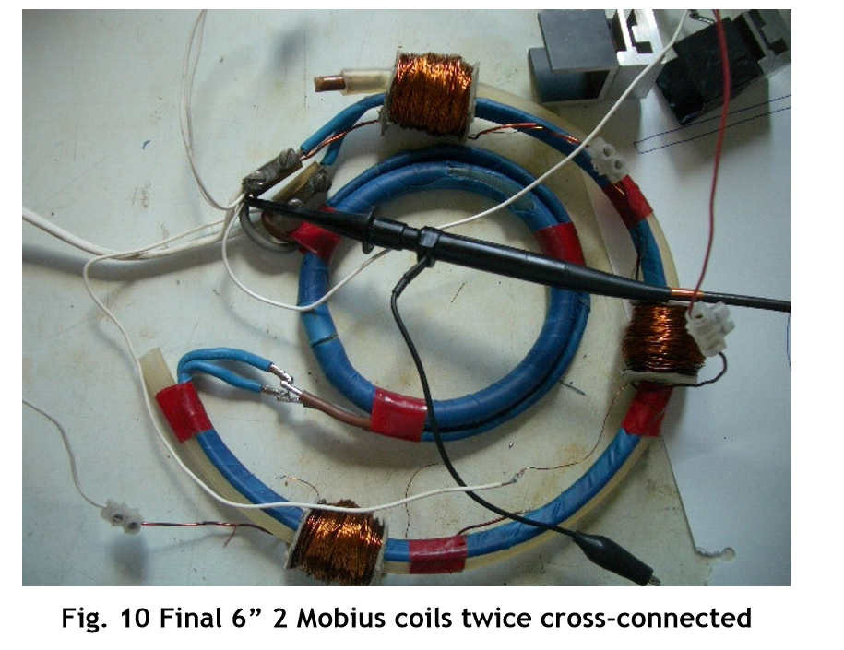
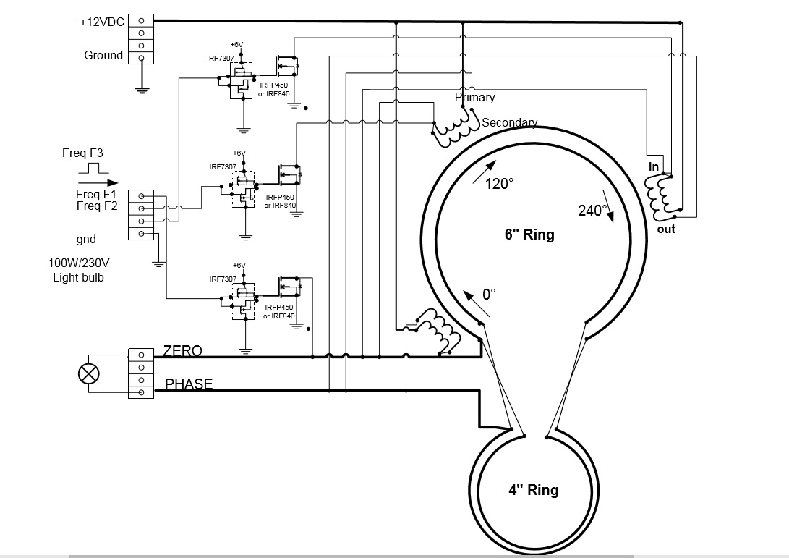

they pulse the coils at different frequenties
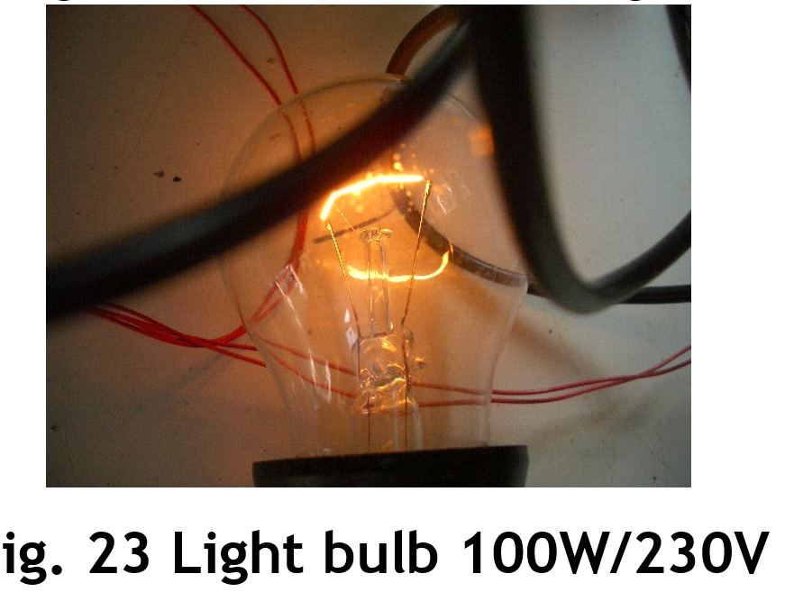

from 12 volt dc to 170 volt ac 100 watts

New research by BOB BOYCE
from hydrogengarage.com
The Bob Boyce Toroidal Power Unit

The Bob Boyce (TPU) is originally the intellectual property of Bob Boyce and has been publicly released open sourced. thank you BOB!!!!! He was offerd alot of money to sel his idea he refused and made it open source!!!

2 operation modes
Power Output - Pulse Mode (Hydroxy controller) Over unity is 4 times the input.

Rotational Mode (Our replication) Over unity is 10 times and greater on the output than the input (up to hundreds of times if tuned correctly and at higher frequencies)

The power output can be anywhere from a few hundred watts to a couple of kilowatts on the safer side. More can be had at greater risk of losing control. Bias potential and magnetic bias play a large role in how much output can be obtained for a given amount of drive energy.
this is what it looks like
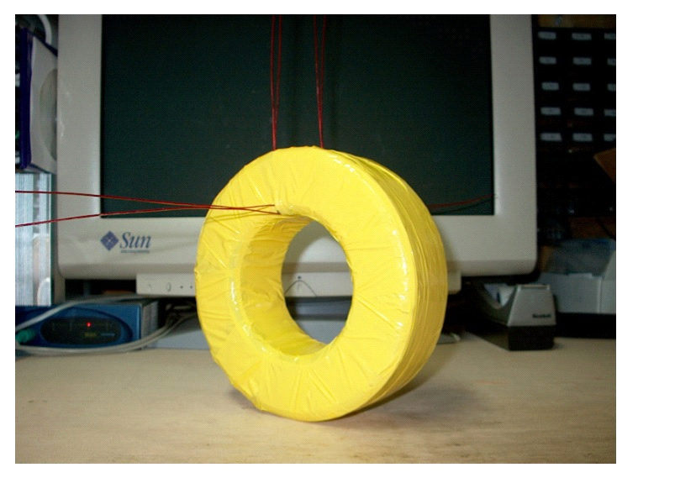
again dangers:

So many are trying to push experimenters to "close the loop", and I offer this warning. That was my first mistake! When I removed the controlled drive energy while feeding part of the output energy back to the input, it triggered a runaway situation that resulted in an energy avalanche. You MUST maintain control, no matter the energy cost. If you must, put in a charging circuit to maintain a battery, and use that battery to run the control electronics. Do not remove the battery or other tightly controlled power source from the system, as this can lead to unstable operation and a runaway condition.

Be extremely careful with radiated energy it could cause an avalange and lightningthunder into your house.

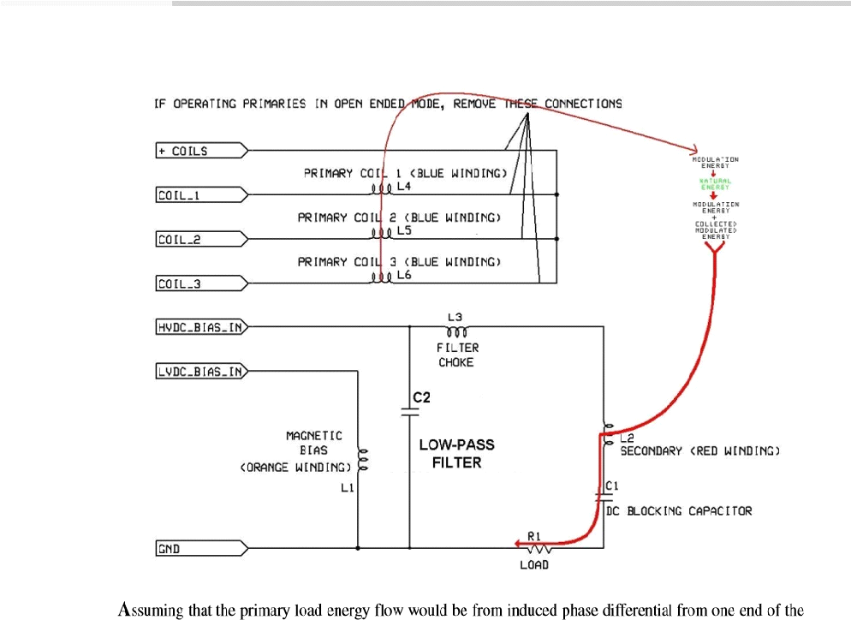

By Tom Van Kleulen ©6 Nov 2016

